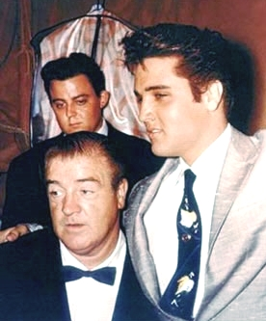
ABBOTT & COSTELLO MEET… ELVIS!
Submitted by Barbara Lee
A cousin of Elvis Presley
Elvis always loved to watch movies and he had a selection of television shows he would watch that would leave him in stitches. To name a few: “The Beverly Hillbillies, I Love Lucy, Gilligan’s Island, Mayberry RFD, the Bowery Boys, Laugh-In, Monty Python’s Flying Circus, The Three Stooges, Martin & Lewis, and Abbott & Costello. Elvis never thought of himself as an actor. Though he did have a strong desire to try his hand at dramatic acting, soon enough Elvis bid goodbye to the cameras and headed back onto the stage, his first love. He still had his favorite actors and actresses and his favorite comedians which gave him pleasure on his down time. Two early film favorites were James Dean and Kim Novak. However, it was the comedians who held Elvis’ attention, mainly because Elvis loved to laugh and to find humor out of tedium and/or tense situations. His was an impressionable and quite contagious laugh that folks were, simply, crazy about. Elvis also had quite a sense of humor and could be extremely quick-witted in any given situation. Whether one-liners or jokes of any kind, Elvis had perfect timing; a hopeless teaser and prankster during the times when he was not ill or melancholy.
Elvis kept a television set in his bedroom where he would confine himself to relax during time off from filming or tours, or sick days. He would have his food sent up and spend hours in bed watching some of those favorite movies and television shows that gave him much joy. Never one to watch his own movies, Elvis quite often would rent out the entire Memphian Theater in Memphis where he and family members and friends could watch some of his favorite films without, himself, becoming the center of attention. Some films even rated a double or triple encore!
The very first motion picture Elvis saw was as a young boy when his father took him to the movies to see “Abbott & Costello Meet Frankenstein.” From that moment on Elvis was hooked on Abbott & Costello!
Their films were among those he faithfully watched yet Elvis, as that young boy, never considered that one day he might meet Bud Abbott or Lou Costello, but…he did! He met both.
Elvis’ success brought with it an ableness to carry out a desire that had been inside him since a small boy, that of helping those less fortunate. One of the foremost humanitarians of his time, and still, today, his estate gives money to charity, Elvis admired others whose humanitarian efforts also alighted on such a grand scale. Al Jolson, Danny Thomas, Lou Costello, and there were more, however, these three Elvis truly admired given the scope and duration of their generosity.
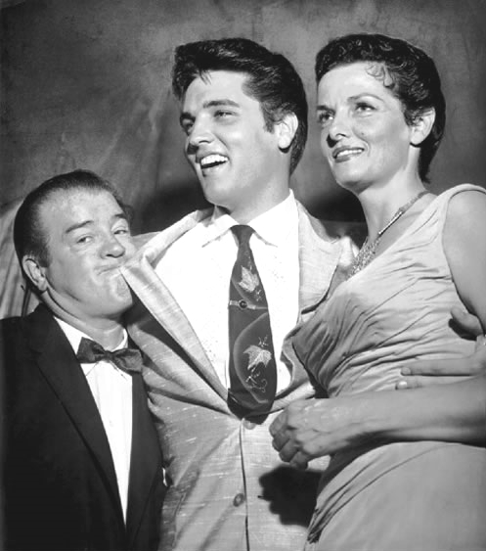
When Elvis made a brief appearance before 11,000 people at Danny Thomas' "Shower of Stars," Russwood Park, Memphis, on June 28, 1957, it was one of his earlier charity events for St. Jude's Hospital, founded by comedian Danny Thomas. Elvis did not sing at this event but made a brief appearance.
No doubt, it was a thrill for Elvis to meet for the first time, one of his all-time favorite comedians. Elvis was quite impressed by Lou Costello. As a matter of fact, notice in all of these photos Elvis and Lou standing together during the sessions. It appears the two got along famously!

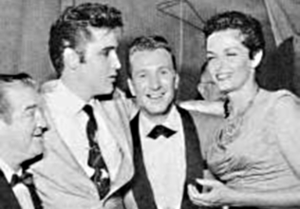
Lou Costello, Elvis, Ferlin Husky, Jane Russell

